**1. INTRODUCTION**

**1.1 Overview**

### What is Search Engine Optimization?

Search engine optimization (SEO for short) is simply the process of obtaining website visitors (or traffic) from ,free, or organic search results in search engines like Google or Bing all major search engines have primary search results that are ranked based on what the search engine considers most relevant to users. We call these organic results, because they are free and not driven by paid advertisements. Search engine optimization helps maximize the number of visitors to a particular website or page by ensuring that the site appears high on the list of organic results returned by a given search engine.

**Here is Google’s definition of SEO:**

Search engine optimization is often about making small modifications to parts of your website. When viewed individually, these changes might seem like incremental improvements, but when combined with other optimizations, they could have a noticeable impact on your site’s user experience and performance in organic search results. You’re likely already familiar with many of the topics in this guide, because they’re essential ingredients for any webpage, but you may not be making the most out of them.

Notice how Google states they are small modifications? There are lots of small changes you can make to your website or blog that will have positive results on ranking. It’s the process of making changes together, in a planned and methodical manner, which drives big results.

### Search Engine Optimization is More Then SEO Factors and Algorithms

An SEO factor is something that influences where a website or piece of content will rank in a given search engine.

No single, standalone SEO factor will produce top search engine rankings. It is the combination of research, planning, and optimization within the website and outside of the website that produces tangible and long-term results. SEO factors have varying weights and no SEO consultant knows the exact weight of each or when these weights change. This is because Google (for example) has over 200 SEO factors and over 10,000 sub-signals for ranking. That is a lot of information to digest and remember. But guess what? You don’t have to remember or even know all of the factors that influence search engine optimization. You just need to learn about what is important and why it matters. Once you have that down, the rest of the details fall into place.

### Why Your Website or Blog Needs Search Engine Optimization

If you’re like most website owners, at one time or another, you’ve asked if your website really needs SEO. It’s a fair question, but one I can quickly dismiss. The majority of web traffic is driven by the major search engines like Google or Bing. Although social media and other types of traffic can route users to your website, the bulk of website traffic is driven by search engines. This statement is true regardless of your website’s purpose. Search engines are powerful because they provide **targeted traffic**. Or in other words, search engines bring users that are seeking what you offer or sell. Targeted website traffic provides revenue and exposure like no other channel of marketing. Investing in SEO can have a much higher rate of return when compared to other types of marketing efforts.

**You need solid SEO to compete online and to obtain traffic. Period.**

Beauty is important and usability is even more critical, however, neither will work for your revenue stream if no one comes to the website. SEO is the tool to drive people to your website or blog.

### Search Engine Optimization doesn’t have to be Scary

Search engine optimization is a long phrase and it can feel very intimidating. I understand it can seem scary, but it doesn’t have it be. Trust me, I was very intimidated by the term SEO when I started learning it over a decade ago. I’m not scared of it anymore, but that is because I’ve spent the time to learn about it and understand it. SEO is not simple and it is not easy. It is part art, part science, and part instinct. But know this – once you get it, you get it and it becomes common sense. We believe that everyone can learn search engine optimization. With enough time and effort, SEO can be learned and mastered by virtually anyone.

**1.2 Problem Statement**

Presently almost every business available in market are having a website to promote their business. However the number of people directly placing URL are way less. Google ranks website based on the steps and tools it has provided for proper ranking of website. Even if the website is way too user friendly with all required information, it may not get ranked in Google due to its algorithmic evaluation method. In our system we will be using Google Tools to rank our website higher in Google search engine.

**1.3 Objectives**

* Perform keywords analysis using Google Ad-words
* Perform Meta-Data configuration.
* Generate a sitemap of website in xml.
* Submit website to Google Webmasters
* Generate Structured Rich cards for website.
* Connect website to Google Business
* Set preferred country location in Webmasters.
* Includes the mobile version in webmasters.
* Generate robots.txt for data restrictions
* Generate keywords competition matrix using Alexa.
* Generate Ad data using Google Ad-words.

1. **Literature Survey**

**2.1 Overview**

**•**The paper clarifies Google's new calculation HUMMINGBIRD which thought to overwhelm SEO systems yet luckily SEO does not have a short life compass. This paper tries to explain the comparison of quality content of different google search algorithms. It also through the light on SEO strategies. The paper concludes with “SEO can never have a short life compass”.

•This paper discusses in detail the technical process of website search engine optimization in terms of the search engine work principle, factors affecting search ranking, and website search engine optimization method.

**2.2 Implementation Methodology**

Search engines are very complex, and you won’t understand all the smaller details or nuances of SEO right away. That being said, as you learn more about the way your site is ranked and track your progress, you will see real results on Google and can adapt your methods. From reading the remainder of this article, you'll learn the basics of search engine optimization, and how to create an effective SEO strategy by following Google’s algorithm guidelines and understanding the ranking factors for success. The first step to creating an SEO strategy is to understand what keywords you're going to rank for.

**Discover Your Keywords & Pillar Pages**

The first step in the overall SEO process is to create a good pillar strategy with high-quality keywords. Very recently, an SEO industry expert, Rand Fishkin, described a new ground breaking SEO strategy. This new strategy is called a "pillar page strategy" or "10x content" and it aims to make your content work 10 times as hard. Pillar pages are the pages on your website that you want to generate the most traffic and are often the pages that have the best analytics.

That means that they could have the following KPIs:

• High traffic levels

• A high amount of time spent on page

• A low bounce rate

• A high click-through-rate

It can be a long, lengthy process to create a pillar page strategy that your company needs, but we've put together a 4-step guide that will help any beginner understand what pillar pages and keywords are the most effective for your company, firm, or business.

Step 1: Choose Your Pillar Pages

Put yourself in the shoes of your ideal client. What would you search for if you needed the products, services, or processes that your company offers? Now, think of the pages that your client base would use the most. There really isn't a limit to the number of high-impact pages that you can use here, but be careful not to go overboard. You don't want to create a pillar page strategy that is beyond your company's capacity. However, if you need to create a 10+ pillar page strategy, and you have the resources needed to accomplish that task, go for it.

**Step 2: Determine Your Keywords**

Evaluate the keywords that your company is using. Where does your website rank for those terms? Are your competitors ranking for keywords that you're not considering? Really do your research here. The better your keywords are, the more traffic you'll be able to receive from Google. The objective here is to gather as many keywords as you deem necessary. We'll evaluate whether or not these keywords are the ones that you should be ranking for in the next step.

**Step 3: Utilize SEO Tools**

Now that you have an idea of what your keywords are, you need to confirm that your keywords are correct, and to get suggestions on additional keywords to add. There are many SEO tools out there that can help you here, and we've listed a few here.

• Google Trends

• Moz

• Google Analytics

• Paid SEO Tools:

• Moz Pro

• SEM Rush

• SEO Power suite

These tools are all fairly comprehensive, but they will take some time to master. Take the time to read their blogs, and get yourself accustomed to the tools' usage. If you have questions that you can't find answers to, contact the support team of the tool that you're using.

**Step 4: Check Your Rankings**

While you are going through step 3, make sure you are denoting what page you're ranking on or what rank you are on the SERPS. If you see your company's URL, make a note of what rank you are. If you don't make these notes now, then you'll have no determinant of whether or not your company is growing or falling in search engine rankings. If you have gone through 50 or 100 search results and still do not see your site, just stop there and make a note of it in your spreadsheet (i.e. 50+ and 100+).

**Basic Steps:**

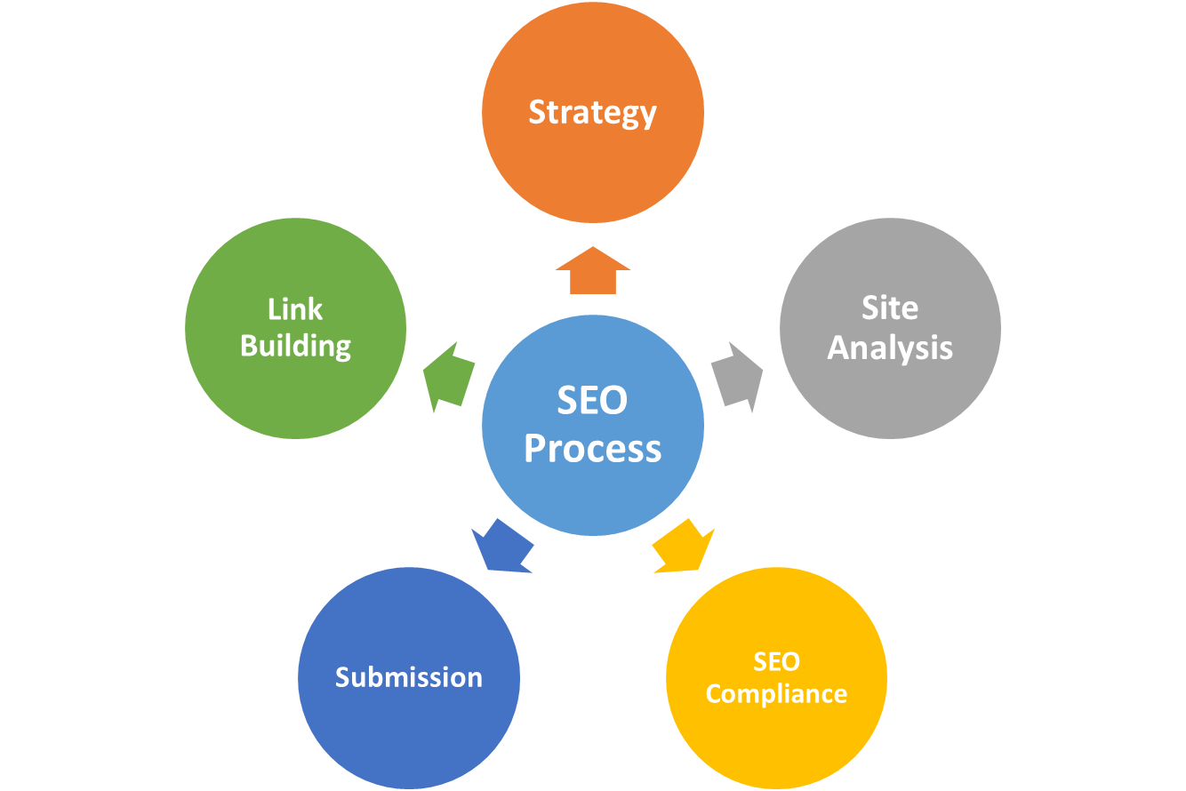

1. **Work Done**

**3.1 System Architecture:**

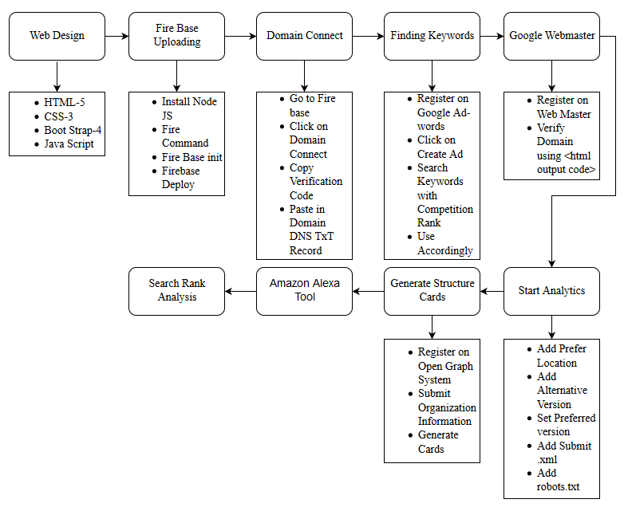

* 1. **Module Description**

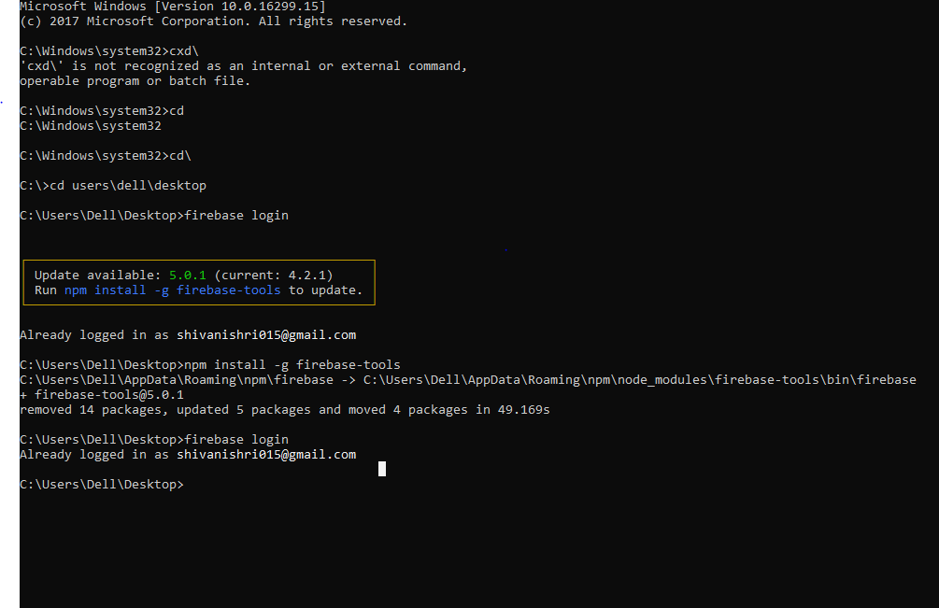

**Fig: Firebase Login**

* For Logging in to Firebase Firebase Login Command is used via Terminal or Command Prompt.
* Where you have to sign in through registered Firebase or Google Account to Access your firebase console from Command Prompt.



**Fig: Firebase Initialization**

* After getting Sign in **Firebase init** Command is used to Initialization of host to firebase, then we have to choose hosting through the list given.
* Set path of your public directory to use it as your public directory in Hosting Website.
* Type ‘Y’ to Configure Single Page app as index.html
* Skip the Over Ride Function to upload your index page.
* Then after checking certain parameters Firebase Initialization is completed.



**Fig: Firebase Initialization**

* The last Command for finishing the hosting phase is to deploy it on Fire base. Ad-hoc firebase deploy command is used.
* After the Hosting is Completed URL of hosting our website is provided with https secured protocol thus, we can access our site via the URL after deploying.

**Hardware Requirement**

* I3 Processor
* 2GB RAM
* 320 GB ROM

**Software Requirement**

* Notepad++
* Node JS
* Java 7
* Firebase
* Alexa

1. **Summery and Conclusion**

**4.1 Summery**

To summarize, the following are the main characteristics search engines look at to determine where to rank your site in their listings:

* Quality of your content
* User engagement with your website
* Site loading times
* Links from other websites to yours (back links)

Two main factors have remained a constant: quality content and back links.

Google and the other search engines look at the above factors (plus many more) and then use them to decide where to list your website for many individual search terms or keywords.

While the search engine algorithms are constantly being refined and updated, with many hundreds of factors being taken into account, two main factors have remained a constant: the quality of your content and the links leading back to your site.

**4.2 Conclusion**

Search engines are very complex, and you won’t understand all the smaller details or nuances of SEO right away. That being said, as you learn more about the way your site is ranked and track your progress, you will see real results on Google and can adapt your methods. As after adapting SEO methodologies we will be able to rank our pages higher in Google Search engine.

**5. References**

**[1] C. Lin, R. Yazdanifard, "How Google's New Algorithm Hummingbird Promotes Content and Inbound Marketing", American Journal of Industrial and Business Management, vol. 4, no. 1, pp. 51-57, 2014. Show Context Cross Ref Google Scholar**

**[2] Liao Jianshuang, On the corporate website optimization techniques SEO Technology [J]. Science and Technology Wind 2009 (8), 117-118. Zhang Nan, Lou Xinyuan. SEO search engine theory and practice [J]. 2010 (10), 14-16.**